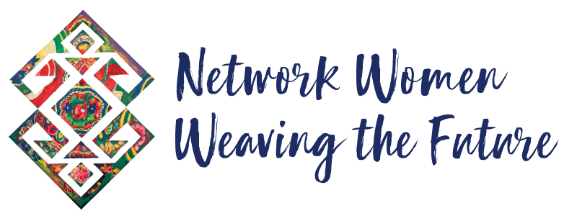
Dear comrades, dear friends,
On August 3, 2014, the so-called Islamic State committed a genocide on the Ezidi community in Shengal. Thousands of people were massacred, and even more were displaced. Women and children were abducted by this brutal group, which used sexualized violence and exploitation as a building block of its power. Ezidi women have resisted from day one and they continue to do so daily. The whereabouts of hundreds of people are still unknown.
Eight years later, on August 15, 2021, the Taliban violently returned to power in Afghanistan, devastating the lives of millions of people. After decades of war and occupation, peoples in Afghanistan once again confronted unlivable conditions under murder, torture, and imprisonment. Minoritized and oppressed communities such as the Hazaras have been specifically targeted.
In both cases, the powers that claim to offer solutions to misery and injustice stood by as the world watched the tragedies unfold. These brutal developments happened with the complicity of the international system of states. We cannot divorce the Islamist violence of the Taliban and ISIS from the colonial state powers that profit from cycles of endless violence in our region.
As always, the most vulnerable bear the consequences: women and children.
Once again, women in our region have seen that we cannot – and must not – wait for anyone to come to our rescue. We must develop our self-defense and self-organization in all spheres of life. We must struggle together to protect ourselves and each other against patriarchal violence. We must not normalize these genocidal and feminicidal episodes as matters of the past. Daily, women in Shengal, Afghanistan, and in many other parts of the world suffer the impact of genocide, occupation, and violence. It is time for us to step up our efforts to demand justice and liberation.
Earlier this month, the Kurdistan Women's Communities (KJK) Coordination announced the launch of a campaign in solidarity with women in Shengal and Afghanistan, calling on organized struggle around the world from August 3-15th. As the Network Women Weaving the Future, we invite you all to join this call for freedom.
Be creative - organize protest actions, information events, and campaigns in your cities. Hold artistic events, mobilize your organizations, and activate the media. Please do keep us posted on your activities. We will use our existing platforms to circulate your actions. We want women in Shengal and Afghanistan to see, hear, and feel our solidarity.
No matter what we do, we must emphasize and condemn the global connections that create conditions of war, violence, and occupation around the world. As struggling women and peoples, it is our moral and political duty to amplify the resistance of our sisters and join forces to enable their freedom. Their freedom is our freedom.
Nobody will be free until our sisters in Shengal and Afghanistan are free!
In solidarity,
Network Women Weaving the Future committee

